MS Centre
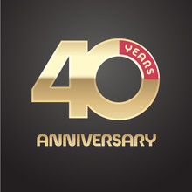
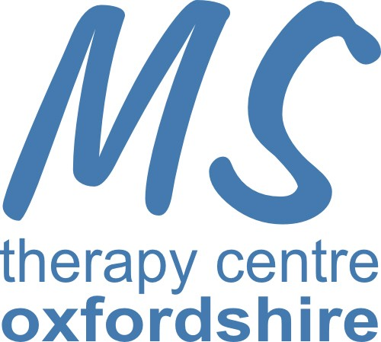
40th Anniversary
May 2024

How it all began:
We started in May 1984 as a charity called “Action and Research into Multiple Sclerosis” (A.R.M.S) and were a breakaway from the MS Society.
The unit was set up by a devoted group of supporters as an independent charity under the ARMS umbrella. Margaret Speight was Chair, Brian Amos, Secretary and along with Maggie Amos and Peter Thomas raised money for the Charity. Their main interest was that June Thomas, an MS suffer (daughter of Margaret Speight) should get oxygen therapy. Beryl Slater joined the Centre as Treasurer in May 1984. They raised £100,000 in cash and kind and offered oxygen and support at highly subsidised rates, backed by Dr David Perrins, one of the world’s leading physicians specializing in hyperbaric medicines.
An EGM was called on 23 October 1991 at Seacourt Towers and a small group of us were told that Margaret Speight, her daughter and son-in-law, Maggie, and Brian Amos, no longer felt able to continue with the burden and if no-one else took over the unit would close. A new company “Oxford Area Friend of ARMS Ltd” was set up and given a bank account of £2,500, later augmented by £28,000 reserves when they decided the charity was in safe hands.
Since activating the company we added a physiotherapy room, became computerised and considerably extended the scope of the unit and services offered.
ARMS built up a very respected and high profile, funding crucial research into oxygen therapy, physiotherapy, nutritionists and counselling at the Central Middlesex Hospital as well as Rosie Jones Unit at Bristol Royal Infirmary and the research at Brunel and Stirling. Saachi and Saachi designed the original ARMS logo, we have now become the “MS Therapy Centre Ltd (Oxford)”.

Location
For the first year from May 1984-1985, we were in a warehouse. Milton Park then wanted to redevelop that area and so we moved in 1985 to a new location in one large portacabin which comprised of an office, reception, kitchen, 2 toilets and the oxygen unit. A physiotherapy room was later added in 1995 and a large portacabin, which can be divided into two therapy rooms, was added in February 2004 because we had become very cramped.
Beryl Slater a founding member who also had MS, became Hon Treasurer 1985-1990 when the Centre became a Limited Company. Beryl received a John Eldridge Award for Voluntary Service in 2001 and a Milton Park Recognition award in August 2009. She remained as a Trustee until she retired from ill health and many people still attending the centre will remember her. She passed away at the age of 91 on 11th February 2020.

The current Centre Manager Sue Doran, started with the centre in September 2005, Sue is part-time. We have 8 Trustees, 15 volunteers and 5 self-employed therapists. Therapists at the centre include Physiotherapist, Manual therapist trained in Osteopathic technique, Footcare technician, Acupuncturist, Masseur, Reflexologist. Our USP is our oxygen chamber, which takes up to 6 people and is beneficial not only for people with MS but for wound healing, broken bones, and many other conditions. We also have a small, specialised gym. We offer subsidized therapies to people with MS, their carer’s, and those with other conditions. We rely totally on donations and fundraising and do not receive any funding.

